Template of Hardware Metapaper

For submission to the *Journal of Open Hardware*

To complete this template, please replace the blue text with your own. The paper has five main sections: (1) Overview; (2) Quality Control; (3) Application (4) Build Details (5) Discussion.

# (1) Overview

## Title

The title of the hardware paper should focus on the hardware, e.g. “[type of hardware] to automate laboratory protocol X” or “Surface Trawl for Collecting Marine Microplastics.” If the hardware is closely linked to a specific research paper, then “[Hardware type] from [Paper Title]” is appropriate. The title should relate to the functionality of the hardware and the area it relates, to rather than making claims about the usability or user characteristics of hardware, e.g. “Easy-to-use”.

## Sport Analyzer: Multi-sensor device for data acquisition and visualization in sport performance and rehabilitation.

## Paper authors

1. Last name, first name; *(Lead/corresponding author first)*

2. Last name, first name; *etc.*

1. Cano-Ferrer Xavier (First/corresponding Author)

2. Imbert, Albane

## Paper author roles and affiliations

1. First author role and affiliation

2. Second author role and affiliation *etc.*

1. Research Engineer, Making Science Technology Platform, The Francis Crick Institute, London, United Kingdom

2. Head, Making Science Technology Platform, The Francis Crick Institute, London, United Kingdom

*Note: One author can have multiple affiliations and affiliations can include “independent”.*

## Abstract

A short (up to 250 words) summary of the hardware being described: what problem(s) the hardware addresses, what it does, how it technically/methodologically advances the state-of-the-art, how it was designed and implemented, and its applicability to other issues/research/areas of reuse.

In this paper we introduce Sport Analyzer, a battery powered device which records and displays force and velocity signals simultaneously and a small footprint. It provides a universal interface circuit for optical incremental encoders and load cells and calibration guides that will allow sport scientists, physiotherapists and medical scientists to build their own hardware and understand how to convert an industrial sensor in a human movement device.

|  |
| --- |
| Metadata Overview *Please provide the following overview and self-assessment*  Main design files: link to repository with design files and assembly instructions <https://github.com/XaviCanoFerrer/Sport_Analyzer>  Target group: e.g. secondary school students, layperson, undergraduate students, scientists in [discipline], trained engineers, use of professional services  Scientists, professionals or undergraduate students in the following disciplines: sport science, sports medicine, physiotherapy, biomechanics.  Skills required: For each main manufacturing method, provide information pairs (method - easy / advanced / specialist). E.g. desktop 3d printing - easy; surface mount PCB - advanced; injection moulding – specialist  Laser ablation – easy; Mechanical assembly – easy; Electrical assembly – advanced; Software – easy.  Replication: Project has been replicated at time of publication? Include reference (possibly way of contact). Links to places where future builds and kits might be found (repository, group website, collaboration site, etc.).  *See section “Build Details” for more detail.*  No builds known to the authors so far. Device has been used by authors for a paper currently in preparation. Keywords *(required)* keyword 1; keyword 2; etc.  Keywords should make it easy to identify who and what the hardware will be useful for. Maximum of 5 keywords. E.g.: microbiology; laboratory; microfluidics; single cell analysis; fluorescence  Biomechanics, velocity-based training, rehabilitation, sport science, encoder. |

## 

## Introduction

An overview of the hardware, what it does, how it was produced, and the research for which it has been used. If the hardware addresses a specific lack or problem, describe the problem in this section and how the hardware addresses the problem. Elaborate how it technically/methodologically advances the state-of-the-art including references to relevant research articles and online references.

In Sports science, sports medicine and physiotherapy two of the most valuable mechanical variables that can be used to control performance, fitness and health are force and velocity. It is well established the use of certain movements or tests to evaluate imbalances that can be related to pathologies or injuries as well as sport gesture performance analysis that can be correlated with a specific training program or method. Between all sensors used for sport performance and rehabilitation, incremental encoders and load cells are some of the most effective to measure velocities and forces associated with physical evaluation tests or exercises. In the case of linear and rotary encoders, they have been extensively used in sport sciences publications to predict the maximal dynamic strength of athletes from the Load-Velocity relationship [1, 2, 3], to evaluate reliability of other velocity and power measuring devices [4, 5] and measure concentric and eccentric power in inertial squat performance [6, 7] between other applications. Load cells have also been used extensively in multiple applications such as: measurement of maximum voluntary contraction or isometric strength (MVC) [8], the instantaneous and average force applied during concentric and eccentric contractions in inertial exercises [6] or simply measure forces from different nature such in the case of elastic bands [9]. The aim of the present work is to describe how to manufacture and reproduce a hardware-based device which can display and record signals from both sensors.

There are two main products in the market which address this need, the pioneer product of the field is the MusclelabTM which interfaces different types of sensors with acquisition units that are connected to its specific software [10]. The other manufacturer which provides load cell and encoder data acquisition by interfacing these sensors with a computer is the Chronojump Boscosystem® [11]. Both products are based on a computer software which interfaces with the sensors through a data acquisition unit (Musclelab) or Chronopic (Chronojump). The main difference of the present device in front of these two commercial products are the only open source hardware approach without the need of software for the acquisition and visualization as well as its completely reproduction at cost price and the battery powered approach which enables its use on any environment. Sport Analyzer pretends to connect the sport science and rehabilitation professionals with the open hardware approach. On the other hand, Virtube [12] and Gymaware [13] are products composed by only one linear encoder which connects wirelessly with smartphones or tablets therefore, they present the portability advantages but they don’t have the load cell capability.

Table 1. Comparison of Sport Analyzer with other available hardware. Cost was obtained from the public prices (Chronojump, Virtube and Gymaware) or from distributors (Musclelab).

|  |  |  |  |  |  |
| --- | --- | --- | --- | --- | --- |
|  | Sport Analyzer | Chronojump | Musclelab | Vitrube | Gymaware |
| Load cell | Y | Y | Y | N | N |
| Linear encoder | Y | Y | Y | Y | Y |
| Rotary encoder | Y | Y | Y | N | N |
| Battery powered | Y | N | N | Y | Y |
| Requires computer software | N | Y | Y | Y | Y |
| Open source software | Y | Y | N | N | N |
| Open source hardware | Y | N | N | N | N |
| GUI for data visualization | N | Y | Y | Y | Y |
| Cost (GBP) | 179.99 (parts) | 773.22 (from Chronojump) | 2,467.77 (from Simplifaster) | 339.75 (from Virtube) | 2,353.43 (from Gymaware) |

Problematic: Systems available are expensive or computer dependent and no hardware based

***Table of the different commercial options***

***Figure with examples of figures of exercises to show applications***

***Table of capabilities***

## Overall Implementation and Design

Describe how the hardware was implemented/created, with relevant details of the architecture and design, including general materials (*Note: specific details on materials can be addressed in later section “Availability of materials and methods”*). The use of diagrams and pictures of the assembled hardware is appropriate. Please also describe any variants and associated implementation differences.

Sport Analyzer is a programmable, Arduino compatible and battery powered device for simultaneous data collection and visualization of two important variables in sport sciences and rehabilitation which are force and velocity. The device accomplishes it by combining a load cell and optical incremental encoder data acquisition (Figure 1a).

System Architecture

The device has been designed to provide the visual image of a linear or rotary encoder and a load cell signals and at the same time acquire their data and save it inside a MicroSD card. It provides the simplicity of having one pushbutton to change the signal displayed and another to place a numeric label associated with the number of sample acquired. The device is battery operated using a regular 9V alkaline battery which also provides availability (Figure 1b).

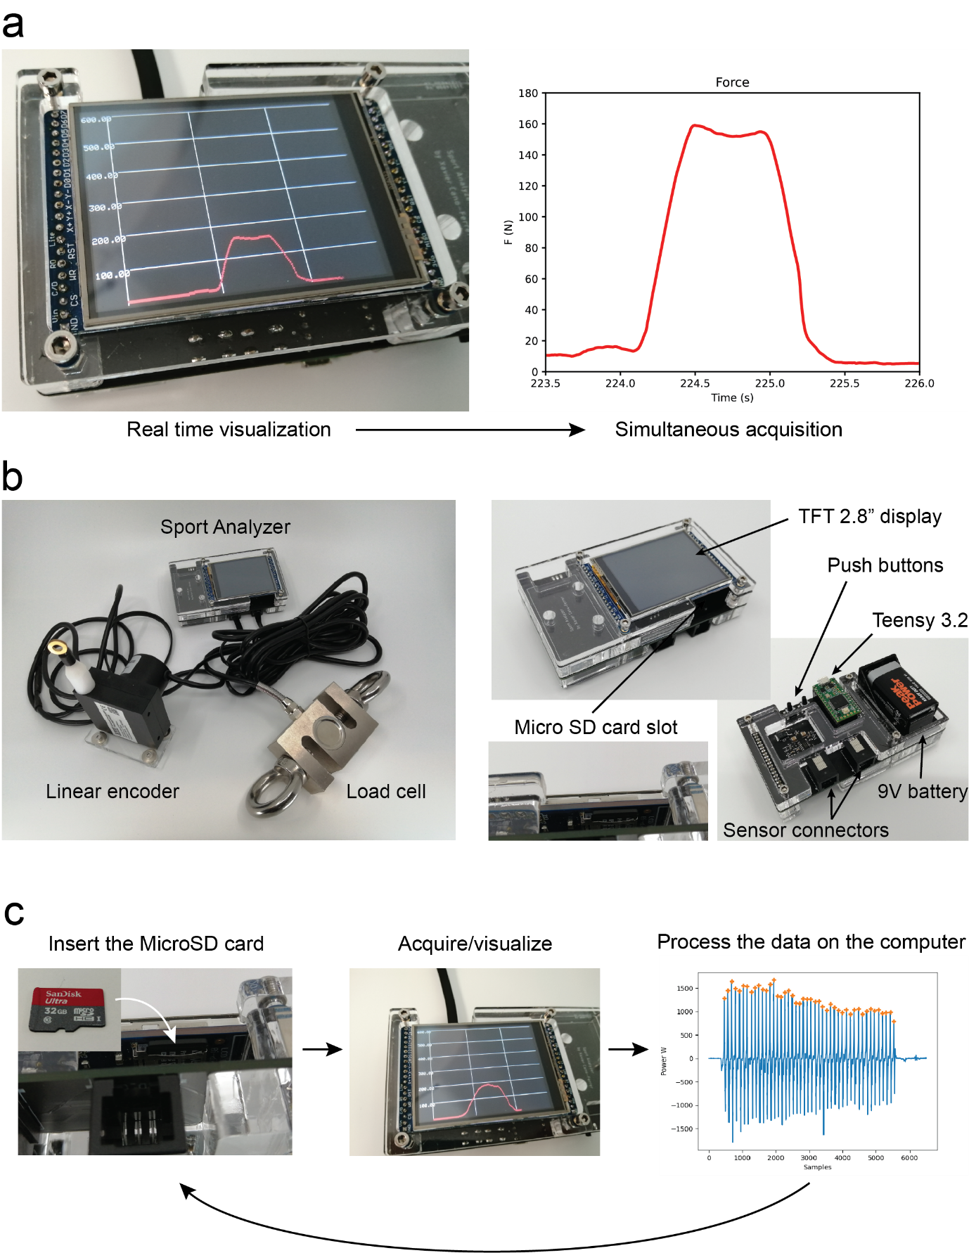

Figure 1: a. Sport Analyzer allows simultaneous data visualization and acquisition for its further analysis. The figure shows the same signal during the acquisition on the TFT display (left) and after the analysis in a plot from the data extracted from the txt. file (right). b. The device with the linear encoder and the load cell connected (left) and the main components of the device (right). c. The device is conceived to have an SD card logging data from both sensors constantly while is being used, after the Micro SD card can be connected to the computer and it can be analyzed.

Electronics

The device main control unit is the Teensy 3.2 development board (Freescale Semiconductor MK20DX256). It has two RJ12 connectors which allow the connections for the Linear or rotary encoder and the load cell. It has a TFT 2.8” display (Adafruit 2.8" TFT LCD with Touchscreen Breakout Board with Micro SD Socket - ILI9341) which also has a Micro SD card socket where the device stores the data collected from the sensors in a txt. file. The device has two pushbuttons, the first one allows the user to switch from displaying the encoder signal (in color blue) and the load cell signal (in color red) on the TFT screen. The second pushbutton increments a counter to label the first column of data of the txt. file stored on the MicroSD card. The load cell conditioning signal is operated by a HX711 (24-Bit Analog-to-Digital Converter (ADC) for Weigh Scales, Avia Semiconductor). The optical incremental encoder signal admits 5V A, B and Z phases connection directly on the Teensy 3.2 pins, which are 5V tolerant. The device is powered using a regular 9V battery (Figure 2).

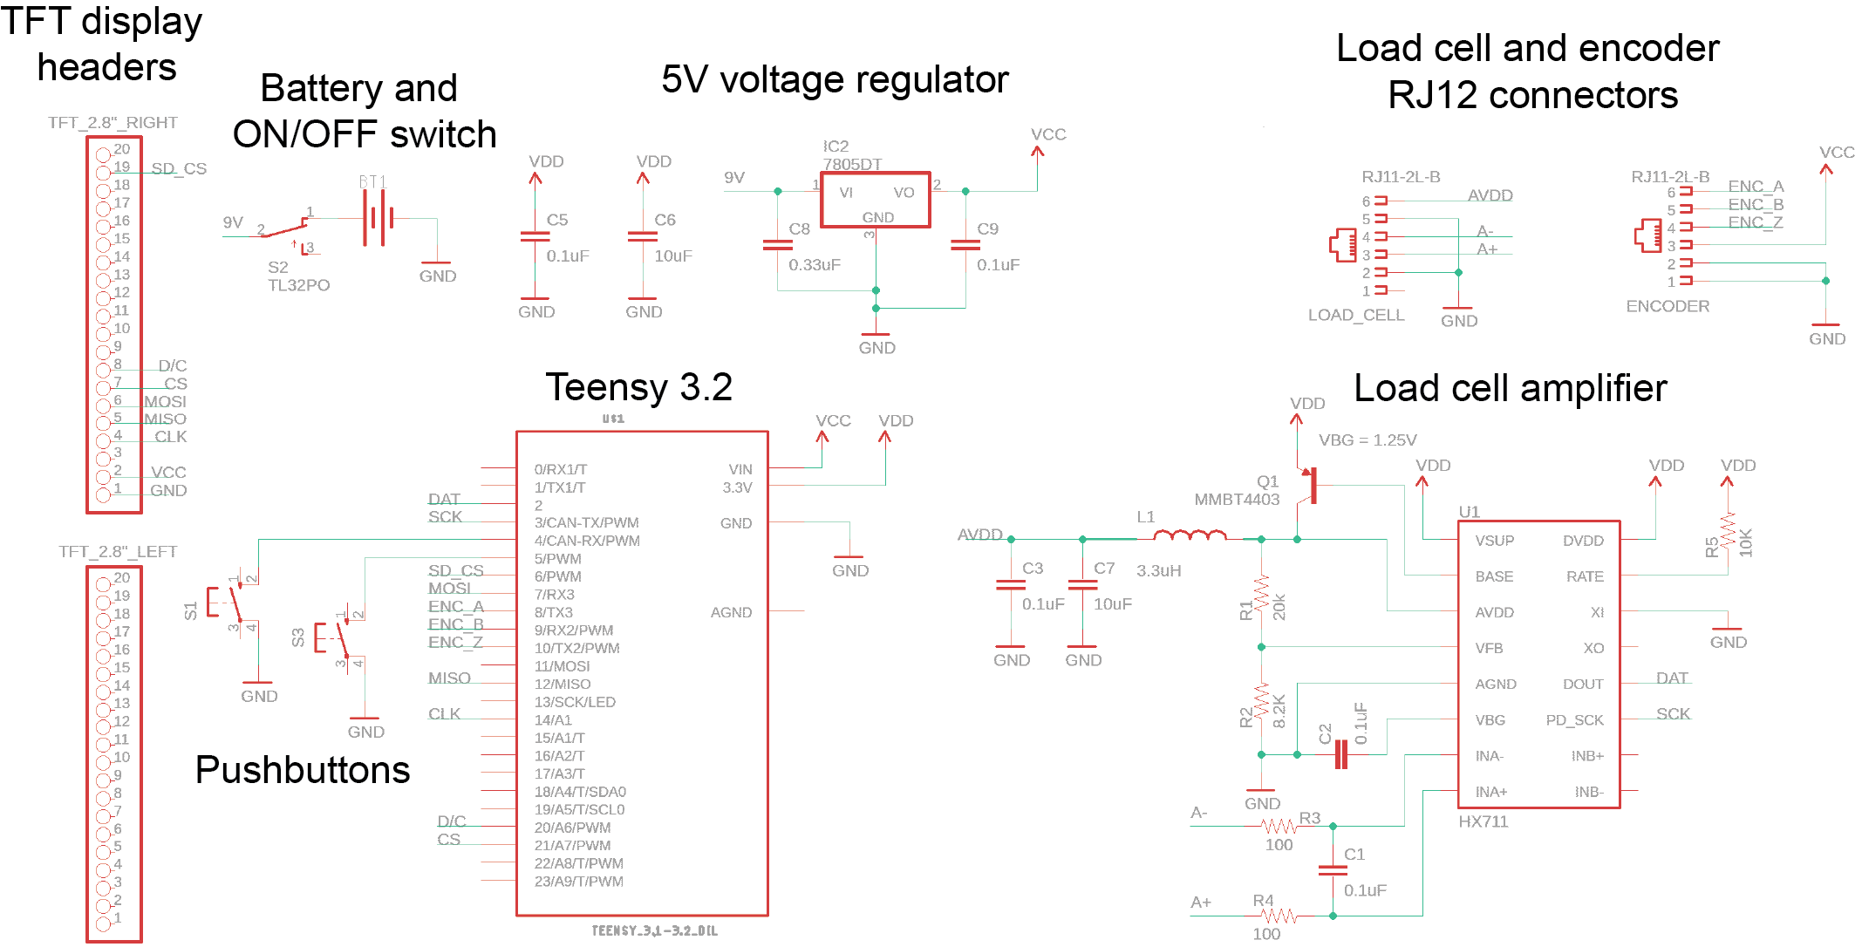

Figure 2: Electronic schematics of the device. Sport Analyzer schematic is composed by the Load cell amplifier circuit, the Teensy 3.2 development board, two pushbuttons, an ON/OFF switch, the two RJ12 sensor connectors, a 5V voltage regulator which converts the 9V of the battery and the TFT display pin headers.

Sensors

The optical incremental encoder used in the present work is a Wisamic with 2400 pulses per revolution with a response frequency of (0-20) kHz and a maximum speed of 6000 rpm. On the other hand, the load cell is an S-type load cell which allows compression and tension forces measurement. The load cell main electrical properties are defined by the sensitivity of 2.0mV/V, repeatability of ±0.02 (%F.S.), Input impedance of 350±10Ω, Linearity of ±0.02 (%F.S.) and a measuring range of 4.9-4900 N (5-500 kg).

Case

The device case has been designed to be manufactured either laser cut or 3D printed. It is a minimalist design to protect the device integrity with minimum complexity. It is composed by three layers: top, middle and bottom and M3 screws and hexagonal spacers.

Firmware

The firmware which is constantly running on the main loop function on the Teensy 3.2 is composed by its main file: Sport_Analayzer_1.0.ino which uses mainly six libraries: the SPI library [14], the ILI9341_t3 library [15], the font_Arial library [16], the Bounce library [17], the Encoder library [18], the SD library [19] and the HX711 library [20]. A part from the libraries, there are essential parts of the firmware that are based on the work of other authors, this functions are: the function that generates a graph for TFT displays [21] and the application we use to generate the code from the Sport Analyzer logo bitmap [22].

The main loop function of the firmware runs inside a three hundred samples for loop which is enough to fill the horizontal axis of the screen. For every iteration, a reading of the pushbuttons, load cell and encoder is performed and saved on the MicroSD card by calling a function called save_sd_card(). The velocity is computed every defined interval, which is by default 10 milliseconds and then the graph function is called displaying the desired signal. After the last iteration of the for loop the TFT display is restarted.

On the lines 21 and 46 v_max and F_max are the variables to change the maximum range of the vertical axis of velocity in the when displaying the encoder signal and the force when displaying the load cell signal. Two Boolean variables called linear_flag and rotational_flag enable the linear or the rotational conversion of the encoder pulses.

The firmware developed for the device is available on:

<https://github.com/XaviCanoFerrer/Sport_Analyzer/tree/main/Firmware>

*Note: This is not meant to be an assembly instruction. Assembly instructions, detailed material lists, and construction files must be deposited in an appropriate repository (see Repositories document) and referenced in section “Build Details”.*

### Subsections

We encourage the use of subsections to highlight the modular functionality of the design or to highlight different design achievements. These questions might help you find appropriate subsections: What parts of the hardware could be used as a component of another project or a variation of this hardware? What solutions do you find most noteworthy given your experiences during the design iterations? What separate actions does the hardware perform?

# (2) Quality control

## Safety

Describe all relevant safety issues or reference to a risk assessment if included in the hardware documentation. Detail what safety considerations have been included in the hardware design and how these features have been tested, including any official safety standards or criteria that were used in this assessment. If appropriate, discuss the wider context of use of the hardware and safety issues or risks that may arise in the use environment.

The device has been designed to use a 9V battery as a power supply, and it draws 120 mA DC and it is considered low current, but the electrical hazard exists and it has to be taken seriously. Precaution has to be taken to place the battery on the battery holder as the device has no inverse polarity protection and it would damage the device permanently. Also 9V batteries Some safety considerations have to be taken with the load cell maximum load which is 4900 N (500 kg) in the proposed on this work. The same applies for the maximum cable extension of the linear encoder which is up to 1.5 meters. Those limits will change if other measurement equipment is chosen.

## Calibration

If the hardware is used for measurements, please detail here how the reliability of measurements, or other hardware properties that are relevant for measurements, has been quantified and explain the results. Be clear about the processes or procedures used to compare the hardware to a standard, as well as the description of the standard calibrated against.

Detail the general procedures in place for users to calibrate their hardware before or during use. What methods can be used to relate user generated data to data from other sources?

The calibration procedure of the device has been done using a calibration.ino program, this piece of code can be found on the calibration folder (<https://github.com/XaviCanoFerrer/Sport_Analyzer/tree/main/Calibration/Calibration>). It displays the raw values of the sensors connected to the Sport Analyzer. In the case of the load cell is a positive or negative value corresponding to an extension or compression stress and in the case of the encoder, the value corresponds to the absolute number of pulses related with its angular position. Excel sheets are provided on the calibration folder of the repository to re-calibrate the load cell and the incremental encoder in case other sensors are chosen.

Load cell calibration

The load cell (Wytino) was calibrated in the first place by measuring its weight with a scale (Kern ECB 50K50) which is approximately 0.8 kg. The value of the load cell’s weight is added on the measurements together with seven weights of known values attached vertically with the load cell measuring the vertical deformation (Figure 3a). The value that corresponds to the zero measurement is the value displayed when the load cell is in horizontal position. The relationship of the load cell reading (value of voltage converted by the 24-bit ADC) and the weight is linear with R = 0.9999 and force function F = 0.0011x - 1.248 (Figure 3b).

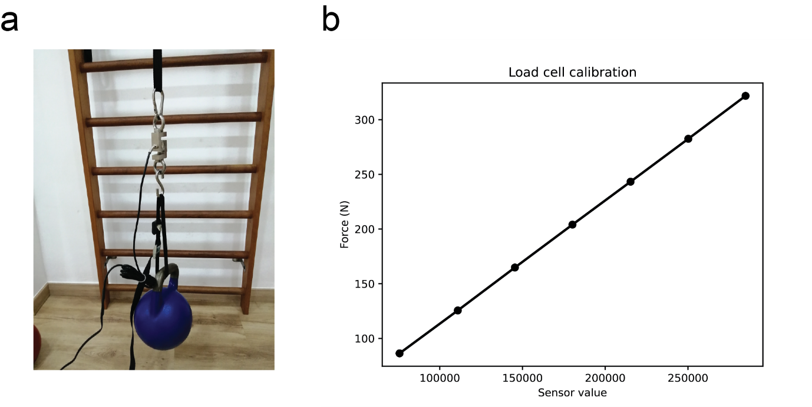

Figure 3: a. Calibration process of the load cell, seven loads of known values are suspended from the load cell. b. Load cell calibration function.

Linear encoder calibration

The linear encoder is composed by two components, the rotary incremental encoder (Wisamic) and the wire draw mechanism (Calt) which converts the rotary movement into a spring loaded linear movement. Its calibration has been performed by placing a measuring tape on a flat surface and measuring 15 times a 0.5-meter distance (Figure 4a). From the samples on Figure 4b the resulting resolution is calculated as the travel in mm divided by the average number of pulses which results in 0.063 mm per pulse.

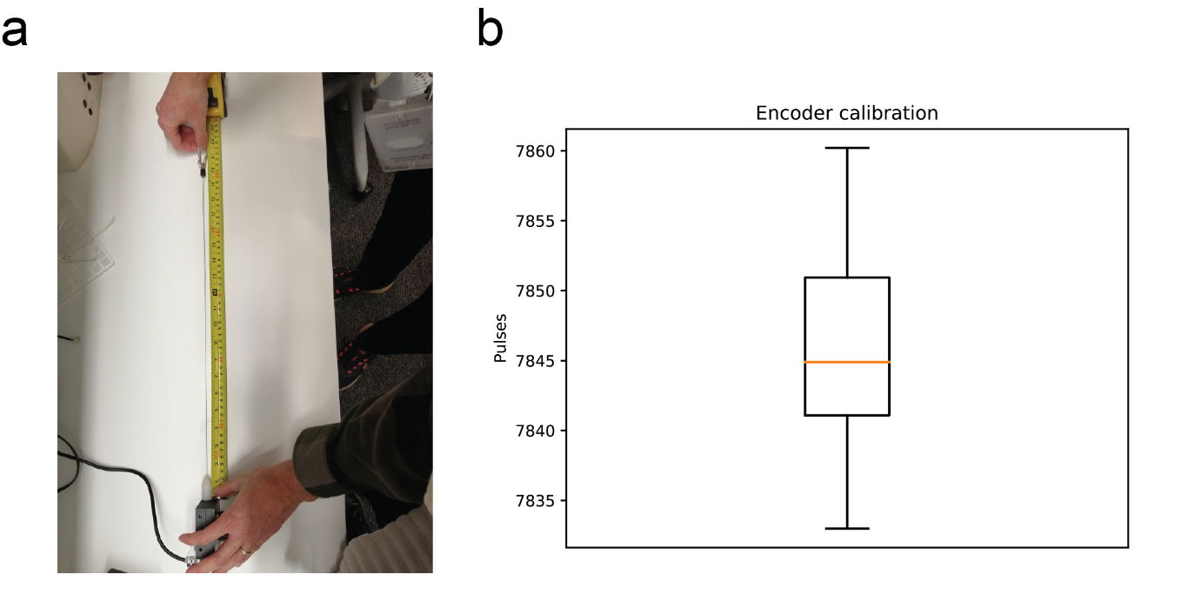

Figure 4: a. Linear encoder calibration process which consists on repeatedly (N = 15) measure 0.5 m distance and collect the number of pulses at the maximum extension. b. The bar plot shows the mean and standard deviation of the pulses that corresponds a cable extension of 0.5 m.

Rotary encoder calibration

In the case of the rotary encoder no calibration is needed as the angular position measurement is the intended use of it. The proposed optical incremental encoder (Wisamic) has 2400 pulses per revolution so the resolution is given by the ratio between 2π radians and the number of pulses with approximately 2.62 mrad/pulse.

*Note: Detailed instructions belong in documentation; here, provide insight into how and why the calibration is valid.*

### Subsections

We encourage the use of subsections within all sections to increase clarity.

## General testing

In this section, details can be provided on the testing of hardware functionalities, that are not directly essential for precision operation of the hardware in the given context (which are in turn, where applicable, handled under Calibration), such as automated movements to position the hardware, repeatability of tool exchanges, recyclability, water-tightness, weight or other possibly relevant characteristics. We encourage the authors to characterise all appropriate functionalities of the hardware, if not already described elsewhere (add reference instead). The testing should define the safe/reliable limits in which the components can be operated (e.g. step size and repeatability of linear motion, force ranges, ratio of devices with leaks when built in a workshop, etc). This will enhance the usability of the hardware or method in other contexts.

Additional information from the device has been evaluated experimentally. The device weights less than 200g without the sensors and the battery (Fisher Scientific CSC 501). The current consumption (120 mA) has been measured using a Hameg HMP4040 power supply at 9V. The sampling period of the Sport Analyzer acquiring both sensors and displaying the signal has been measured the difference in milliseconds between samples logged on the SD card, it is approximately 13 milliseconds. The main characteristics are resumed on Table 2.

Table 2. Sport Analyzer main characteristics.

|  |  |  |
| --- | --- | --- |
|  | Value | Units |
| Sampling Frequency | 78 | Hz |
| Weight (without battery) | 194.4 | g |
| Power | 1.08 | W |
| Autonomy (standard alkaline 9V battery) | 4.5 | h |
| Linear encoder resolution | 63 | µm |
| Load cell resolution (Theoretical using a 24 bit ADC) | 0.1 | mN |
| Rotary encoder resolution | 2.6 | mrad |
| Maximum encoder measuring distance (Supplier information) | 1.5 | m |
| Maximum load cell measuring force (Supplier information) | 4.9 | kN |

*Again: Detailed instructions belong in documentation; here, provide a summary instead.*

# (3) Application

## Use case(s)

Describe at least one example of an application of your hardware. This should include some evidence of output, e.g. data produced by the use of the device or a picture of other types of results. Outline how the quality control in the previous section enables the use of the hardware in this context. We encourage the inclusion of experiment results or the reference to a publication (published or to-be-published) where these results are detailed. We also encourage pointers to ongoing work.

Combined measurement of angular velocity and force in inertial resistance training

The first use case provided is using the load cell simultaneously with the encoder in the rotary encoder configuration to acquire angular position and velocity and force at the same time in a unilateral row with a conical/inertial pulley (Figure 5a).

Measurement of forces suspension training devices

One of the main examples on Sport Analyzer helps to visualize provides a clear picture of the data that cannot be measured in any other way such as dynamic exercises performed using rigid devices such as suspension training devices where the force is unknown because it is applied against a rigid strap. In Figure 5b the eccentric and concentric contractions can be clearly identified in the exercise cycle. The plotted signals are averaged across 3 repetitions.

Monitoring of isometric contractions in physiotherapy evaluation and treatment

In Figure 5c We present a comparison between right and left arm during maximum voluntary contraction (MVC) isometric force in the shoulder external rotation (the plotted signals are averaged across 3 repetitions). This is an example of how it can be used to find differences between healthy and injured joints, in this case could be used to identify difference related with shoulder impingement syndrome or EMG associated with shoulder isometric muscular contractions [23]. This example is extremely valuable to show that the device can provide visual feedback to rehabilitators and physiotherapists during isometric exercises with patients.

Measurement of velocity and relative power

The device can be used to determine the relative linear power during a physical movement. In Figure 5d we show its performance recording a Bosco jump test which consists on repetitive counter-movement jumps (CMJ) for 60 seconds [24]. From this experiment several valuable indicators can be extracted: such as the relative power and the fatigue index between 0 and 15 seconds and between 0 and 60 seconds. This has been used for decades to classify and compare athletes from different disciplines and standardize its performance level.

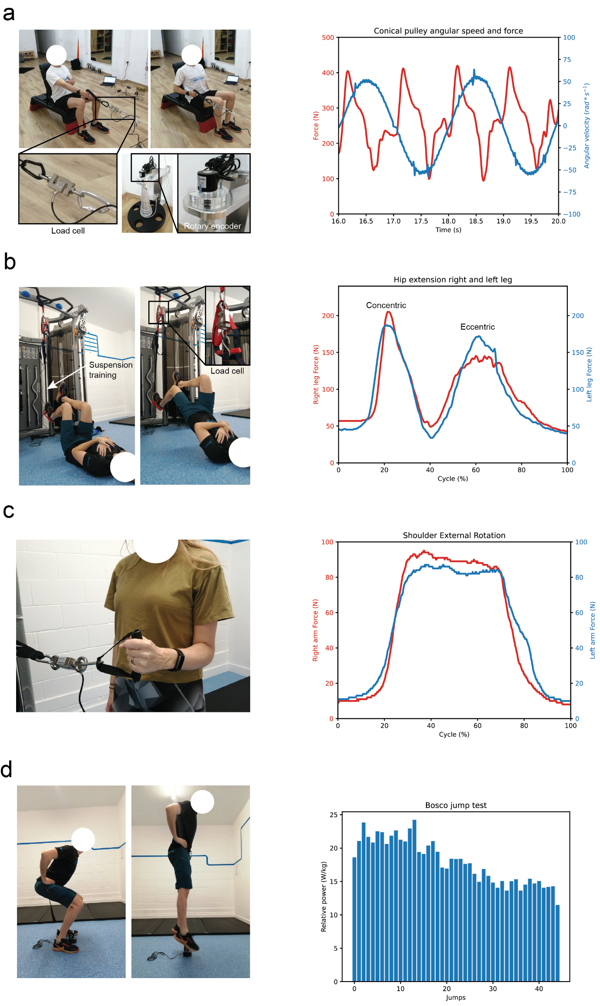

Figure 5. a. Unilateral row in an inertial conical pulley with simultaneous acquisition of force and angular position. b. Hip extension performed in a suspension trainer with a load cell attached. c. Shoulder external rotation isometric maximum voluntary contraction against a load cell. d. Counter movement jump (CMJ) with a linear encoder measuring linear displacement and velocity which allows the estimation of the relative power of each jump performed during a 60 second Bosco test.

*Note: In the spirit of openness, we require authors to provide (or link to) datasets along with the submitted graphic representations. We do not impose arbitrary limits on inclusion of data so please include sufficient empirical detail and results to ensure your data can be easily verified, analysed and clearly interpreted by the wider scientific community.*

### Subsections

We encourage the demonstration of different use cases, divided by sub-sections to guide the reader.

## Reuse potential and adaptability

Please describe in as much detail as possible the ways in which the hardware could be reused by other researchers both within and outside of your field. This should include the use cases for the hardware, and also details of how the hardware might be modified or extended (including how contributors should contact you) if appropriate. Refer to section “Ease of build” where necessary.

Please provide your thoughts on the adaptability of the hardware design. What tools and procedures would it require for other users to modify your design without your help in order to adapt them for foreseeable or even unforeseeable use.

Also you must include details of what support mechanisms there are in place for this hardware and software (even if there is no support or support community).

In the way the manufacturing is proposed, the main components such as the Teensy 3.2 and the Adafruit TFT display can be reused for other devices or for future versions of the Sport Analyzer, reducing the components needed for future versions as they are attached using pin headers. The modularity of the sensor connection ensures that the sensors can be connected to future devices.

# (4) Build Details

## Availability of materials and methods

Summarise what materials have been used to construct the hardware and what methods to process the materials as well as the assembly. Provide more details or references where important materials or methods are non-standard, not globally available or produced only by one manufacturer.

The full bill of materials can be found on the Sport Analyzer repository (<https://github.com/XaviCanoFerrer/Sport_Analyzer/tree/main/Bill%20of%20Materials>) as well as the detailed assembly instructions (<https://github.com/XaviCanoFerrer/Sport_Analyzer/tree/main/Assembly%20instructions>). All the electronic components are widely available and the device has been designed to be easily reproduced, durable and robust.

## Ease of build

Have any measures been taken in the design to make the hardware easy to build for other users e.g. reduction of parts, features in the design to make the hardware assembly more reliable?

All the electronic components are soldered on the PCB without the need of stripping or crimping any wire and providing a more robust and durable design. Some of the electronic components are surface-mount technology (SMT) components and therefore is recommended the use of tweezers to hold them when soldering. The mechanical components have been designed to be manufactured with any technique: the three case components and the encoder base are 2D designs with a certain height which can achieved laser cutting acrylic of different thicknesses or with any 3D printer.

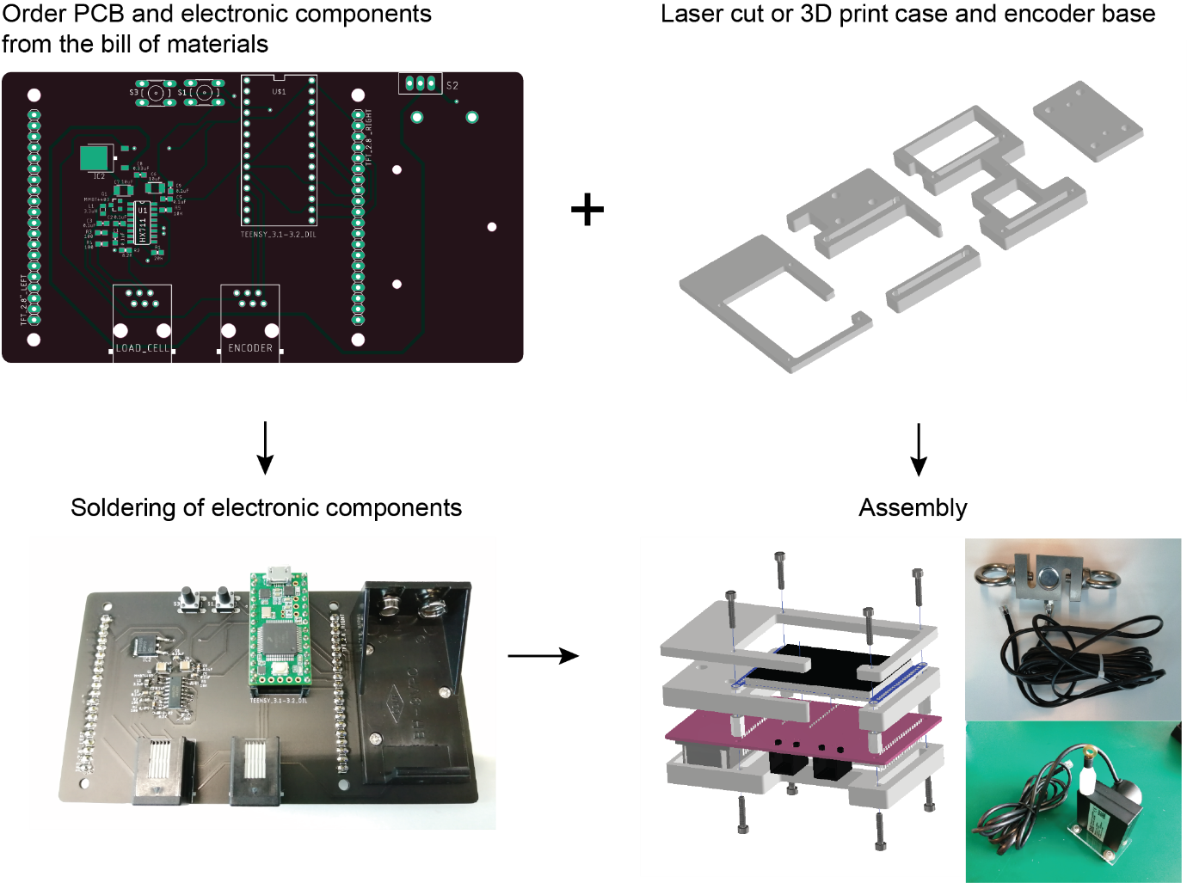

Figure 6. Manufacturing process workflow diagram.

## Operating software and peripherals

If hardware requires software, details on the operating software and programming language - Please include minimum version compatibility. Additional system requirements, e.g. memory, disk space, processor, input or output devices.

If the hardware does not require software, detail any required supporting processes or protocols required for use.

The firmware is upload on the Teensy 3.2 development board using the Arduino IDE and their add-on Teensyduino developed by PJRC. It can be found on the “Firmware” folder of the main repository(<https://github.com/XaviCanoFerrer/Sport_Analyzer/tree/main/Firmware/Sport_Analayzer_1.0>).

## Dependencies

E.g. other hardware or software projects, modular components, libraries, frameworks, incl. minimum version compatibility. Explicitly state if dependencies are proprietary / closed source.

There are no dependencies.

## Hardware documentation and files location:

***Archive*** ***for hardware documentation and build files*** (required. See *Repositories* document for criteria, DocuBricks and alternative repositories.) *Note: We require the inclusion of modifiable design files as well as a detailed documentation of the design rational of the hardware with assembly instructions. This will be assessed as part of the journal peer review process.*

***Name:*** The name of the archive Sport Analyzer on GitHub

https://github.com/XaviCanoFerrer/Sport_Analyzer

***Design files***

https://github.com/XaviCanoFerrer/Sport_Analyzer/tree/main/Design%20Files

***Manufacturing files***

https://github.com/XaviCanoFerrer/Sport_Analyzer/tree/main/Manufacturing%20files

**Assembly instructions**

https://github.com/XaviCanoFerrer/Sport_Analyzer/tree/main/Assembly%20instructions

**Calibration**

https://github.com/XaviCanoFerrer/Sport_Analyzer/tree/main/Calibration

**Bill of materials**

https://github.com/XaviCanoFerrer/Sport_Analyzer/tree/main/Bill%20of%20Materials

***Persistent identifier:*** e.g. DOI, etc.

***Licence:*** Open hardware license under which the documentation and files are licensed - see *Essential author information* for more information

GNU GPL v3.0

***Publisher:*** Name of the person who deposited the documentation Xavier Cano-Ferrer

***Date published:*** dd/mm/yy

**Software code repository** (e.g. SourceForge, GitHub etc.) (required)

***Name:*** The name of the code repository Sport Analyzer on GitHub

***Identifier:*** The identifier (or URI) used by the repository

https://github.com/XaviCanoFerrer/Sport_Analyzer/tree/main/Firmware/Sport_Analayzer_1.0

***Licence:*** Open license under which the software is licensed GNU GPL v3.0

***Date published:*** dd/mm/yy

# (5) Discussion

## Conclusions

Conclusions, learned lessons from design iterations, learned lessons from use cases, summary of results.

This article introduces the design of an open source device which allows monitoring and recording of two of the most important variables to measure patient’s health in physiotherapy and athlete’s performance. It pretends to introduce the sport science and rehabilitation professional communities into the world of making, understanding and customizing their own measuring hardware devices. The devices also opens the perspective of hacking the existing strength and resistance training equipment in order to attach the sensors described and record or visualize the variables of interest. In resume Sport Analyzer can help a wide variety of professionals to collect data for their scientific studies and their daily athlete/patient monitoring by being able to extract: Mechanical impulse, mechanical work, muscle contraction concentric and eccentric power, maximum voluntary contraction (MVC) in isometric muscle contractions, angular and linear velocities between others.

## Future Work

Further work pursued by the authors or collaborators; known issues; suggestions for others to improve on the hardware design or testing, given what you have learned from your design iterations.

The concept of the device developed in this work can be extended including other signal measurements that can help researchers visualize and record other relevant human body measurements such as: electrogoniometer to measure angle joints, contact platforms to measure jump heights, force platforms to display displacement of gravity center of pressure or surface electromyography (sEMG) channels to measure muscular electrical activity (COP). Some of these additions require much higher sampling frequencies which is the case of sEMG (Fs > 1kHz) which complicates the task of displaying and acquiring the signal at the same time.

## Paper author contributions

Task (e.g. design, assembly, use cases contribution, documentation, paper writing), contribution, author name.

XCF: device design and programing, use cases contribution, experimental data, paper writing; AI: paper writing.

## Acknowledgements

Please add any relevant acknowledgements to anyone else who supported the project in which the hardware was created, but did not work directly on the hardware itself.

Please list anyone who helped to create the hardware and software (who may also not be an author of this paper), including their roles and affiliations.

We thank Pau Gómez, Pier Setti, Artur López and Rainiero Avero for the feedback of the functionality of the device based on their extensive professional experience in sport science and coaching. And George Konstantinou for the feedback on the device design.

## Funding statement

If the hardware resulted from funded research please give the funder and grant number.

We want to acknowledge financial support from the Francis Crick Institute founders: Medical Research Council (MRC), Cancer Research UK, The Welcome Trust, University College London (UCL), Imperial College London and King’s College London.

## Competing interests

If any of the authors have any competing interests then these must be declared. The authors’ initials should be used to denote differing competing interests. For example: “BH has minority shares in [company name], which part funded the research grant for this project. All other authors have no competing interests." Or “BH is selling kits and parts connected to the here presented hardware via platform XX. A fundraising via Crowdfunding platform YY is planned to start commercialisation.”

If there are no competing interests, please add the statement:

“The authors declare that they have no competing interests.”

The authors declare that they have no competing interests.

## References

Please enter references in the Harvard style and include a DOI where available, citing them in the text with a number in square brackets, e.g.

[1] Bazuelo-Ruiz B, Padial P, García-Ramos A, Morales-Artacho AJ, Miranda MT, Feriche B. Predicting Maximal Dynamic Strength From the Load-Velocity Relationship in Squat Exercise. J Strength Cond Res. 2015 Jul;29(7):1999-2005. doi: 10.1519/JSC.0000000000000821. PMID: 25881572.

[2] Banyard, Harry G.; Nosaka, Kazunori; Haff, G. Gregory Reliability and Validity of the Load–Velocity Relationship to Predict the 1RM Back Squat, Journal of Strength and Conditioning Research: July 2017 - Volume 31 - Issue 7 - p 1897-1904 doi: 10.1519/JSC.0000000000001657

[3] Bosquet L, Porta-Benache J, Blais J. Validity of a Commercial Linear Encoder to Estimate Bench Press 1 RM from the Force-Velocity Relationship. J Sports Sci Med. 2010 Sep 1;9(3):459-63. PMID: 24149641; PMCID: PMC3761713.

[4] van den Tillaar R, Ball N. Validity and Reliability of Kinematics Measured with PUSH Band vs. Linear Encoder in Bench Press and Push-Ups. Sports (Basel). 2019 Sep 10;7(9):207. doi: 10.3390/sports7090207. PMID: 31509960; PMCID: PMC6784224.

[5] Ferro A, Floría P, Villacieros J, Muñoz-López A. Maximum velocity during loaded countermovement jumps obtained with an accelerometer, linear encoder and force platform: A comparison of technologies. J Biomech. 2019 Oct 11;95:109281. doi: 10.1016/j.jbiomech.2019.07.025. Epub 2019 Jul 31. PMID: 31471113.

[6] Illera-Domínguez V, Nuell S, Carmona G, Padullés JM, Padullés X, Lloret M, Cussó R, Alomar X, Cadefau JA. Early Functional and Morphological Muscle Adaptations During Short-Term Inertial-Squat Training. Front Physiol. 2018 Sep 10;9:1265. doi: 10.3389/fphys.2018.01265. PMID: 30246805; PMCID: PMC6139363.

[7] Lindemann U, Farahmand P, Klenk J, Blatzonis K, Becker C. Validity of linear encoder measurement of sit-to-stand performance power in older people. Physiotherapy. 2015 Sep;101(3):298-302. doi: 10.1016/j.physio.2014.12.005. Epub 2015 Mar 2. PMID: 25796540.

[8] Macaluso A, De Vito G. Comparison between young and older women in explosive power output and its determinants during a single leg-press action after optimisation of load. Eur J Appl Physiol. 2003 Nov;90(5-6):458-63. doi: 10.1007/s00421-003-0866-7. Epub 2003 Jul 19. PMID: 12883896.

[9] Fuentes AD, Smith CJ, Shoepe TC. Loading Patterns of Rubber-Based Resistance Bands across Distributors. Sports (Basel). 2019 Jan 16;7(1):21. doi: 10.3390/sports7010021. PMID: 30654430; PMCID: PMC6358948.

[10] <https://www.musclelabsystem.com>

[11] <https://chronojump.org/>

[12] <https://vitruve.fit/>

[13] <https://gymaware.com/>

[14] Paul Stoffregen, “SPI library for Teensy & Arduino IDE” <https://github.com/PaulStoffregen/SPI>

[15] Paul Stoffregen, <https://github.com/PaulStoffregen/ILI9341_t3/blob/master/font_Arial.h>

[16] Paul Stoffregen, “Optimized ILI9341 TFT Library” <https://github.com/PaulStoffregen/ILI9341_t3>

[17] Thomas O Fredericks, “Debouncing library for Arduino and Wiring” <https://github.com/thomasfredericks/Bounce2>

[18] Paul Stoffregen, “Quadrature Encoder Library for Arduino” <https://github.com/PaulStoffregen/Encoder>

[19] Paul Stoffregen, <https://github.com/PaulStoffregen/SD>

[20] Bogdan Necula, “An Arduino library to interface the Avia Semiconductor HX711 24-Bit Analog-to-Digital Converter (ADC) for Weight Scales.” <https://github.com/bogde/HX711>

[21] Kris Kasprzak, “Functions to draw graphs on LCD” <https://github.com/KrisKasprzak/GraphingFunction/blob/master/Graph.ino>

[22] Jasper van Loenen, “” <http://javl.github.io/image2cpp/>

[23] Reed D, Halaki M, Ginn K. The rotator cuff muscles are activated at low levels during shoulder adduction: an experimental study. J Physiother. 2010;56(4):259-64. doi: 10.1016/s1836-9553(10)70009-6. PMID: 21091416.

[24] Bosco C, Luhtanen P, Komi PV. A simple method for measurement of mechanical power in jumping. Eur J Appl Physiol Occup Physiol. 1983;50(2):273-82. doi: 10.1007/BF00422166. PMID: 6681758.

Martin, L 2010 Bombs, bodies and biopolitics: Securitizing the subject at airport security. Social and Cultural Geography, 11(1): 17-34. DOI: http://dx.doi.org/10.1080/14649360903414585

NOTE: Please include DOIs for all journal articles where possible.

# Copyright notice

Authors who publish with this journal agree to the following terms:

Authors retain copyright and grant the journal right of first publication with the work simultaneously licensed under a [Creative Commons Attribution License](http://creativecommons.org/licenses/by/3.0/) that allows others to share the work with an acknowledgement of the work's authorship and initial publication in this journal.

Authors are able to enter into separate, additional contractual arrangements for the non-exclusive distribution of the journal's published version of the work (e.g., post it to an institutional repository or publish it in a book), with an acknowledgement of its initial publication in this journal.

By submitting this paper you agree to the terms of this Copyright Notice, which will apply to this submission if and when it is published by this journal.